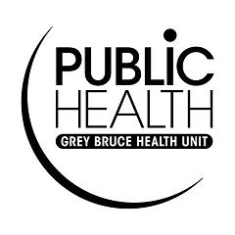
Facility:

Blood and Body Fluid Exposure Response Procedure
(accidental puncture wounds, abrasions, and burns to client or personal service setting worker):
Complete this form if a client is accidentally injured during service. This does not have to include exposure to a worker’s blood or body fluids. You do not have to see blood or body fluids on equipment or surfaces for an infection to occur. Clients are at risk of being exposed to HIV, Hepatitis B, Hepatitis C or other microorganisms such as bacteria or fungi when injuries occur.

- Allow the wound to bleed freely
- Perform hand hygiene and put on single-use gloves prior to handling or dressing the wound
- Wash the area thoroughly with soap and water (do not scrub)
- Apply skin antiseptic and cover the wound with a sterile dressing or bandage
- If splashed in the eyes, thoroughly flush out the eyes with cold water
- If splashed in the mouth, thoroughly flush out the mouth with cold water
- Person exposed should consult with a health care provider as soon as possible regarding the need for post-exposure treatment, work restrictions, or other follow-up
- Document all incidents
- Keep records on-site in a secure location for a minimum of one year, and on file, whether on-site or off-site, for a minimum of two additional years

Record of Accidental Exposure to Blood/Body Fluids

Date of Incident: (dd/mm/yy)

Person Exposed:
Name (first and last) Phone Number

Complete Mailing Address

Procedure being performed:

Site of Injury

Circumstances Surrounding Incident/Injury:

Action(s) Taken:

Name (first and last) of Personal Service Worker Involved:

Phone number

